# 1. Vessel planning tool

The planning tool is developed with VBA in Microsoft Excel and AIMMS for the short sea shipping service in the North Sea area. The tool is developed for a triangle network with three ports, which is also usable for a network of two ports. When using the tool for two ports situation, the user needs to set dummy parameters for the third port and input demand only between two ports. The tool helps to support the decisions on number of vessels to deploy and weekly schedules for the vessels taking into account the loading and unloading of the vessels. The scope of the tool is quay-to-quay as depicted in



Figure : Process and decision problem involved in the business

The tool has three functions:

1. Fleet size optimization
2. Weekly routing and scheduling
3. Port stay time decision support

For each function, the user needs to set input parameters in one or several Excel files. AIMMS retrieves the input parameters and executes the optimization with relatively short computation time. The results are stored in several Excel files.

***Important: Microsoft Excel and the stand-alone version of AIMMS have to be installed. A valid AIMMS license is required.***

AIMMS is the platform of choice for building and delivering apps that improve business performance. The software leverages the power of prescriptive analytics (optimization) to provide companies with a competitive edge and quantifiable results (AIMMS).

# 2. Check tool applicability

Before using the planning tool, an important process is to check the applicability of the tool. Since the tool is developed on weekly base, the sum of average sailing time and port stay time cannot exceed 168 hours. Furthermore, since a set of predefined building blocks for vessel routing is built-in in the planning tool, it is necessary to check whether this building block set covers all the possibilities of vessel routing.

The check mainly depends on the sailing time on each leg and average port stay time. Please follow the steps below to check the tool applicability.

***Step 1***: Open file “*Check tool applicability.xlsx*”.

***Step 2***: Set the ports in the triangle network in column B. Input the “Home port” in cell B3 and the other two ports in cell B4 and B5. Figure 2 shows a specific case. In this case, the home port is Rotterdam, which is represented by “A” in the tool. The other two ports are Hamburg and Immingham which are represented by “T” and “Z” respectively.

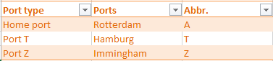

Figure : Set triangle network

***Step 3***: Put the sailing time and average port stay time of each leg in range “F3:G8”. In this case, the sailing time between Rotterdam and Hamburg is 18 hours. The sailing time between Rotterdam and Immingham is 15 hours and between Hamburg and Immingham is 26 hours. The average port stay time for all the ports is 8 hours.

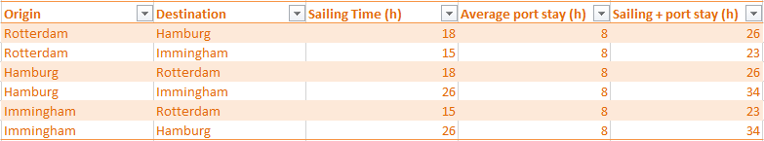

Figure : Set sailing time and average port stay time

***Step 4***: Check the applicability of the tool, which is shown in the same sheet. With the above settings, the tool shows that “The tool is applicable for these 3 ports and pre-defined building block set covers all the possibilities of vessel routing”. When changing the sailing time and port stay time, e.g. changing sailing time between Rotterdam and Hamburg to 100 hours, it shows that “The tool is not applicable for these 3 ports since the sailing time exceeds 168 hours”. For instance, changing the sailing time between Rotterdam and Hamburg to 5 hours, it shows that “The tool is applicable for these 3 ports but pre-defined building block set does not cover all the possibilities of vessel routing”, which means the solution space does not cover all the possible vessel routes.

# 3. Fleet size optimization

## 3.1 Set input parameters for fleet size optimization

The input parameters for fleet size optimization is set in the file “FleetSizeOptimization_Input.xlsm” in the cells marked with pink. The input parameters are separated into two types: basic input and customer info. The detailed steps are shown as follow:

***Step 1***: Open “*FleetSizeOptimization_Input.xlsm*”

***Step 2***: Set total operation time of a vessel in a week, which is less than 168 hours. In this case, total operation time of a vessel is 160 hours. In this way, there is some slack time left in a week to deal with unexpected situation. Set average terminal handling speed (container/h), which is an average number for all three ports. In this case, average terminal handling speed is 16 containers/hour.



Figure : Set vessel total operation time and average handling speed

***Step 3***: Set weekly vessel rents and discount rate if there is discount on the rent of the second and third vessels. Figure 5 shows the settings in this case. Weekly vessel rent is 40000€ and there are 5% discount for the second and third vessel, which means the rent of the second and third vessels are 38000€.



Figure : Set vessel rent and discount rate

***Step 4***: Set volume and weight capacity of the vessel, shown as Figure 6 and Figure 7. Vessel capacity is distinguished by volume and weight for each leg. Volume capacity is represented by a fixed number of TEU volume for each leg. In this case, volume capacity is 400 TEU for each leg. Weight capacity depends on the draft. In this case, weight capacity is 3500 ton for each leg.

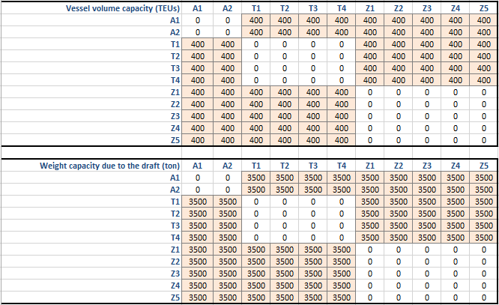

**Origin**

**Destination**

Figure : Set vessel volume capacity



Figure : Set vessel weight capacity

***Step 5***: Set related information of building blocks for routing which include the variable cost and sailing time. Variable cost is the summation of fuel cost and port fee. Sailing time is in hours. Figure 8 shows the settings in this case.



Figure : Set variable cost and sailing time of building blocks for routing

***Step 6***: Set customer information. Customer information includes customer name, origin, destination, weekly demand volume in containers, TUE factors, average weight, unit outsourcing cost (€), unit handling cost at terminal including both loading and unloading (€), unit price if the containers are delivered with own sailing and unit price if the containers are outsourced. Figure 9 shows 38 customers with their relevant information.



Figure : Set customer information

***Note: Total number of customer can be 100 in the tool. However, the computation time grows fast with the increase of the number of customers. For complicated situation, computation time can be several hours.***

***Step 7***: Click the button “Create ranges”

***Step 8***: Click the button “Generate binary parameters (flow within route)”.

***Step 9***: Click the button “Generate binary parameters (flow between routes)”. The process of step 8 and step 9 might take a few minutes, please wait patiently.

***Step 10***: Save and close file “*FleetSizeOptimization_Input.xlsm*”

## 3.2 Fleet size optimization

Fleet size optimization process is executed in AIMMS with the following steps:

***Step 1***: Start AIMMS and open an existing project “Vessel_Planning_Tool.aimms”. Figure 11 shows the start page of the vessel planning tool.

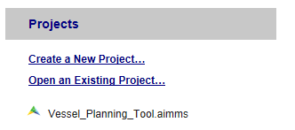

Figure : Start AIMMS and open vessel planning tool

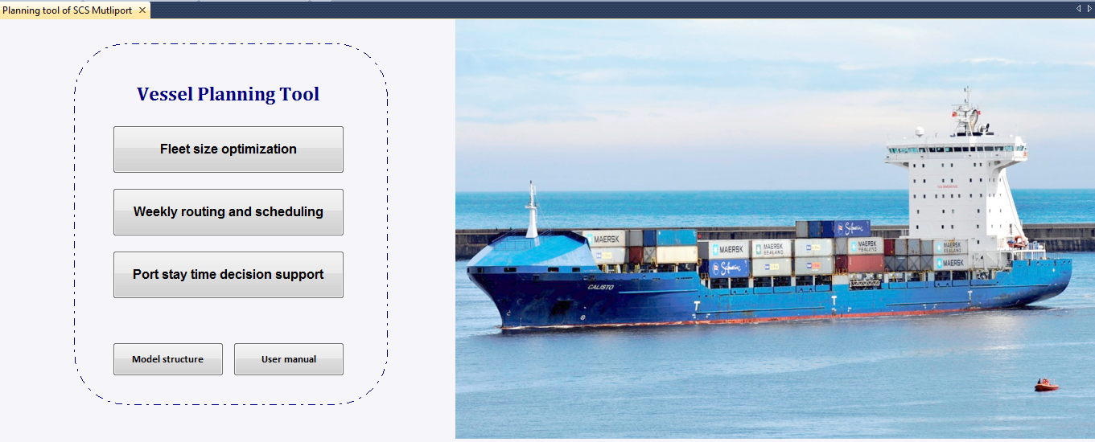

Figure : Start page of the vessel planning tool

***Step 2***: Click button “Fleet size optimization” to select fleet size optimization function

***Step 3***: Click button “Input preparation” to load the input parameters from Excel file. Figure 12 shows part of the input parameters in AIMMS.

***Step 4***: Check the input parameters for fleet size optimization. If the parameters are not correct, make the modification in AIMMS or in the input Excel file. If the user makes modification in the input Excel file, click button “Input preparation” again to reload the input parameters.

***Note: If the customer name, origin and destination are modified, please go back to Excel file and repeat step 7 to 9 of section 3.1.***

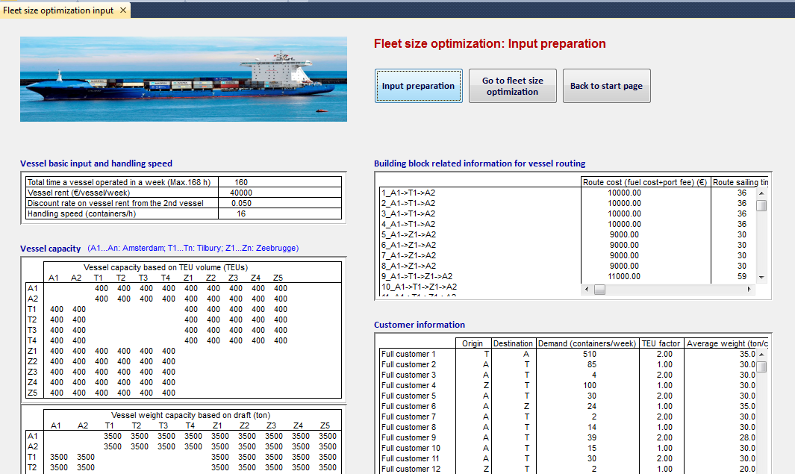

Figure : Load input parameters in the tool

***Step 5***: Click button “Go to fleet size optimization”

***Step 6***: Click button “Fleet size optimization”. Wait until the execution is completed. The computation time varies from a few seconds to a few hours depending on the complexity of the problem. In this case, the computation time is 21 seconds. If the computation time is too long, press “Ctrl + Shift + s” to terminate the execution. The optimization process is terminated with current best solution. After the execution check weekly profit in the same page. Figure 13 shows the weekly profit for this case. From the table, it is possible to check total revenue, total routing cost, weekly vessel rents, total handling cost, total outsourcing cost and total profit. The costs and revenues are also shown in a figure.

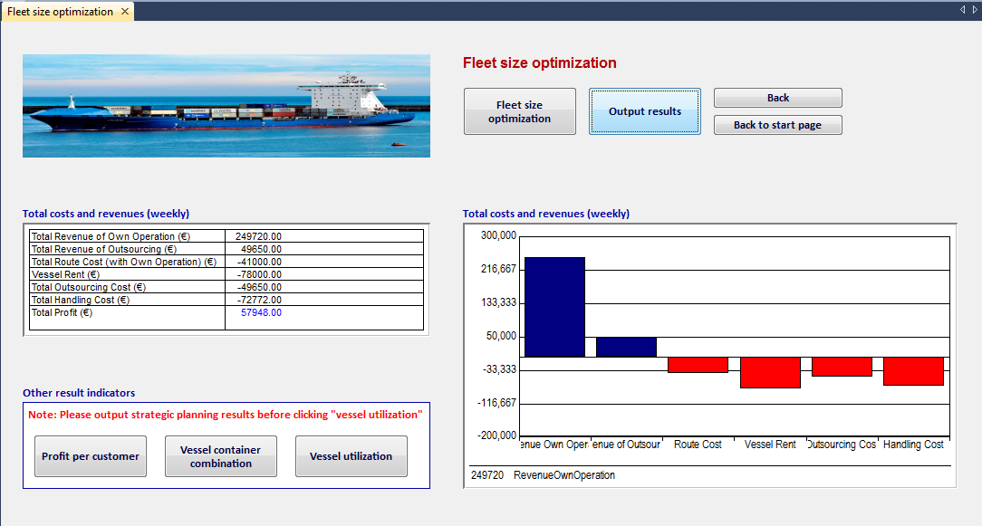

Figure : Fleet size optimization results: weekly profit

***Step 7***: Click button “Output results” to store the results in file “*FleetSizeOptimization_Results.xlsm*”

***Step 8***: Check other results indicators: profit per customer (Figure 14), vessel container combination (Figure 15) and vessel utilization (Figure 16). Profit per customer helps to determine the contribution of each customer. Vessel container combination shows the optimal fleet size and provides general insights into weekly routes. Vessel utilization shows the utilization based on volume and weight capacity.

***Note: Please output the results before checking the vessel utilization.***

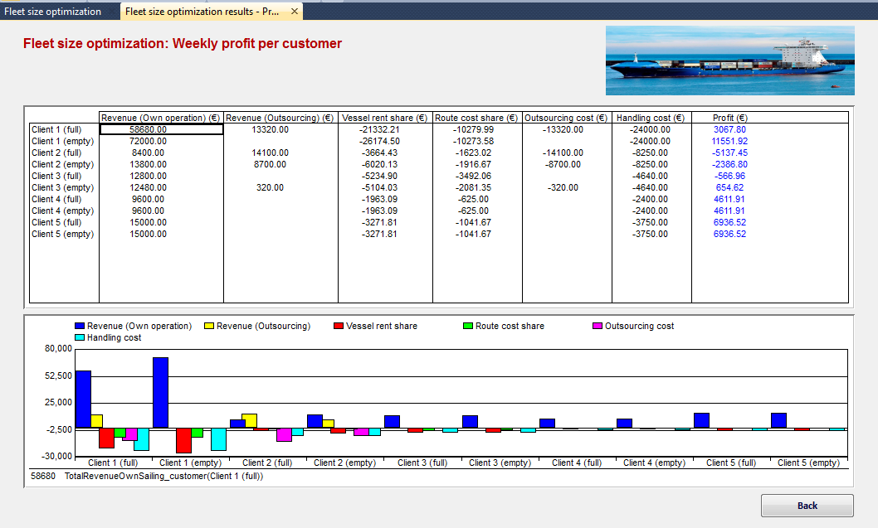

Figure : Fleet size optimization results: weekly profit per customer

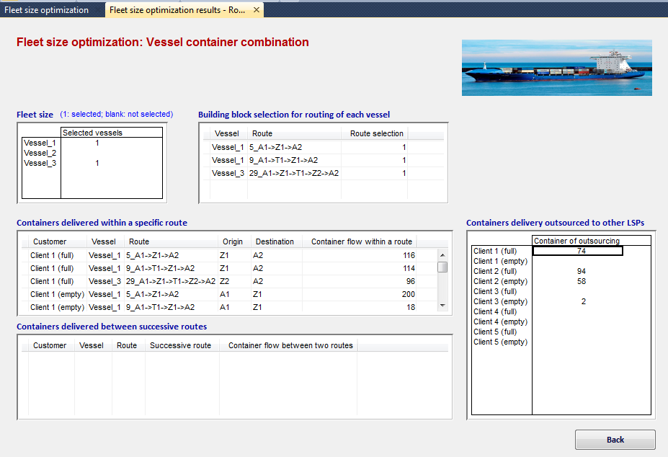

Figure : Fleet size optimization results: vessel container combination

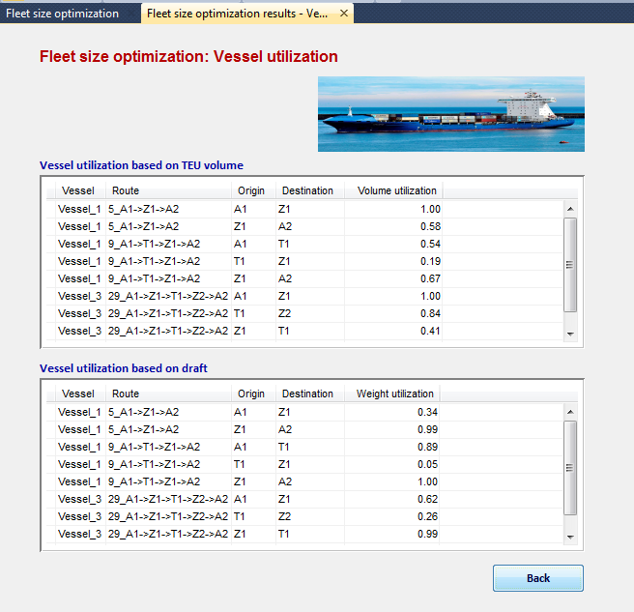

Figure : Fleet size optimization results: vessel utilization

***Step 9***: Open “*FleetSizeOptimization_Results.xlsm*” to further analyze the results.

# 4. Weekly routing and scheduling

In this illustration, we use the same case for the fleet size optimization function. The transportation demand on the triangle network: Rotterdam, Hamburg and Immingham of 38 customers are shipped by 3 vessels.

## 4.1 Set weekly order information

***Step 1***: Open file “*Weekly_Order_Containter_Inventory.xlsm*”

***Step 2***: Set order information. Order information includes the leftover demand from week n-1 and demand of week n for each customer. The leftover demand is the demand available at origin terminal at week n-1 that is not delivered in week n-1. Figure 18 shows the order information for this specific case.

***Step 3***: Set customer related information including TEU factor, average weight (ton/container), unit handling cost (€/container), unit outsourcing cost (€/container), order delay penalty (€/hour), unit price of own sailing (€/container), unit price with outsourcing (€/container), and due date in days or working days and how may days. Figure 17 shows the settings in this case.

***Step 4***: Save and close “*Weekly_Order_Containter_Inventory.xlsm*”



Figure : Customer related information



Figure : Order information

## 4.2 Set input parameters for weekly routing

***Step 1***: Open “*Weekly_Routing_Input.xlsm*”

***Step 2***: Set basic input parameters for weekly routing, which is the same as parameter setting of fleet size optimization. One additional input is the number of vessel. In this case, there are 3 vessels.

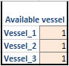

Figure : Set fleet size

***Step 3***: Click button “Load demand”. Input the path of “*Weekly_Order_Containter_Inventory.xlsm*”. Click button “load weekly aggregated demand” to load customer information. For the weekly routing, the orders are aggregated on each customer. The process might take a few seconds to minutes, please wait patiently.

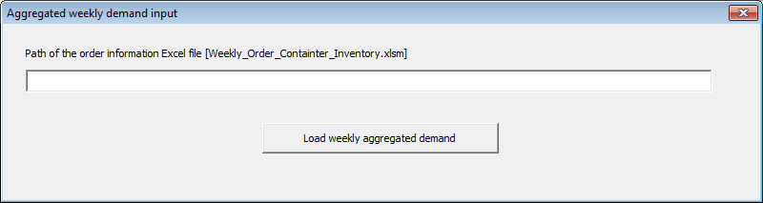

Figure : Input the path of the order information file

***Step 4***: Click button “Create ranges”

***Step 5***: Click button “Generate binary parameters (flow within route)”. The process might take a few minutes, please wait patiently.

***Step 6***: Click button “Generate binary parameters (flow between routes)”. The process might take a few minutes, please wait patiently.

***Step 7***: Save and close “*Weekly_Routing_Input.xlsm*”

## 4.3 Set input parameters for weekly scheduling

In this case, there are 3 vessels. So it is necessary to set the input parameters for each vessel separately. And each vessel starts at and ends in the home port every week. This user manual shows the steps for vessel 1 in detail. The steps for vessel 2 and 3 are the same.

***Step 1***: Open “*Weekly_Scheduling_Input_Vessel1.xlsm*”

***Step 2***: Set basic vessel information for vessel 1: Total operation hours of vessel 1 in a week (cell B1) and handling speed (cell B2).

***Step 3***: Set sailing time on each leg. Figure 21 shows the settings in this case.



**Destination**

**Origin**

Figure : Set sailing time on each leg

***Step 4***: Determine the time slots in a week. In this case we define 7 slots which represent each day in a week starting from Sunday. Figure 22 shows the beginning time and end time of each slot.



Figure : Set time slots in a week

***Step 5***: Set time window for each time slot at each port. The beginning and end port stay time should be within the time slot. In this case, the port stay time at Rotterdam on Sunday is from 9:00 to 14:00 and on Monday is from 7:00 to 19:00.



Figure : Set port stay time window

***Step 6***: Set vessel volume and weight capacity, which is the same as the setting of fleet size optimization function.

***Step 7***: Set service penalty cost including: unit extra labor cost during weekends (€/hour), average loading and unloading time at each port (hour), service early/late departure/arrival penalty cost (€/h). Figure 24 shows the settings for this case.

***Step 8***: Save and close “*Weekly_Scheduling_Input_Vessel1.xlsm*”

***Step 9***: Repeat step 1 to step 8 for vessel 2 and vessel 3. The input parameter setting of vessel 2 and 3 are in files “*Weekly_Scheduling_Input_Vessel2.xlsm*” and “*Weekly_Scheduling_Input_Vessel3.xlsm*” respectively.



Figure : Set service penalty cost

## 4.4 Execute weekly routing and scheduling

Weekly routing and scheduling process is executed in AIMMS with the following steps:

***Step 1***: Start AIMMS and open vessel planning tool

***Step 2***: Click button “Weekly routing and scheduling”

***Step 3***: Click button “Input preparation for routing” to load routing input parameters

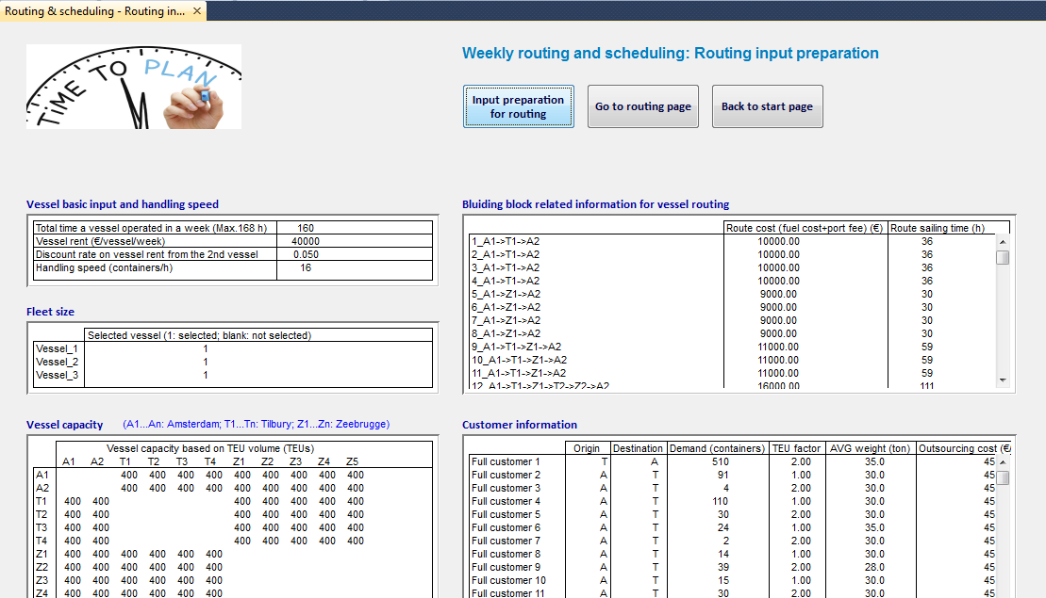

Figure : Load input parameter for weekly routing

***Step 4***: Check the input parameters for weekly routing. If the parameters are not correct, make the modification in AIMMS or the input Excel file. If the modification is made in the input Excel file, click button “Input preparation for routing” again to reload the input parameters.

***Note: If the demand volume needs to be changed, please make the changes in the file “Weekly_Order_Containter_Inventory.xlsm”. If the customer name, origin and destination are modified, please go back to Excel file and repeat step 4 to 6 in section 4.2.***

***Step 5***: Click button “Go to routing page”

***Step 6***: Click button “Vessel routing (upcoming week)”. Wait until the execution is completed. The computation time varies from a few seconds to a few hours depending on the complexity of the problem. In this case, the computation time is 122 seconds. If the computation time is too long, press “Ctrl + Shift + s” to terminate the execution. The optimization process is terminated with current best solution. After the execution check weekly profit in the same page. Figure 26 shows the total profit of upcoming week for this case.

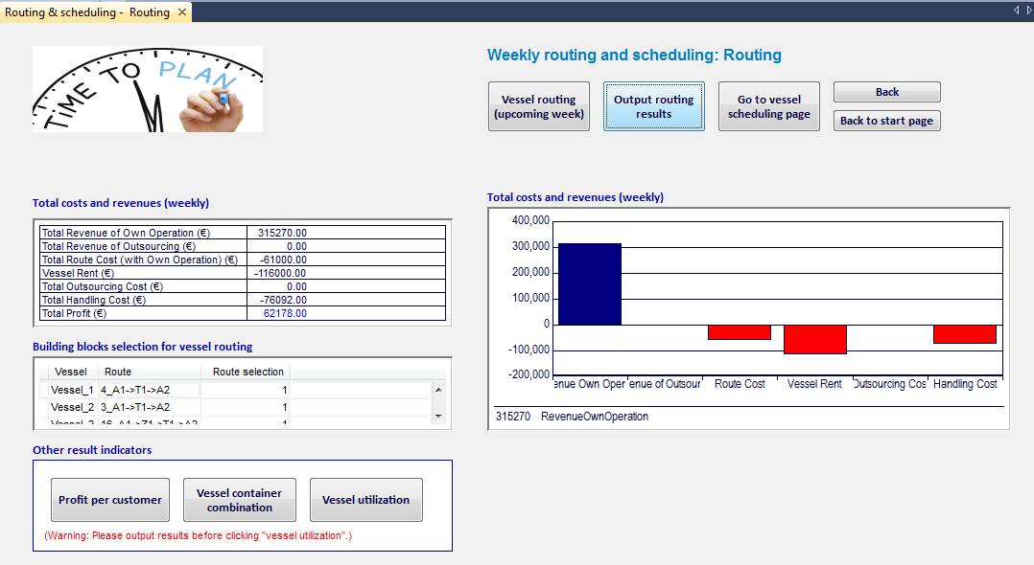

Figure : Weekly routing results: total profit

***Step 7***: Click button “Output routing results”. Input the path of weekly routing results file “*Weekly_Routing_Results.xlsx*”. Click button “Output routing results”.

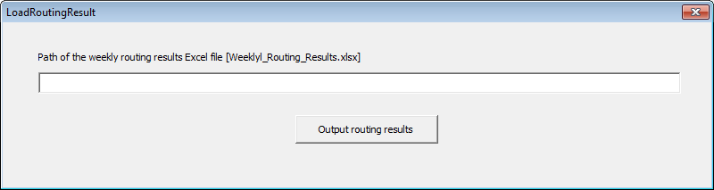

Figure : Output routing results to Excel file

***Step 8***: Click the buttons shown in Figure 28. Check other results indicators: profit per customer, vessel container combination and vessel utilization.

***Note: Please output the results before checking the vessel utilization.***

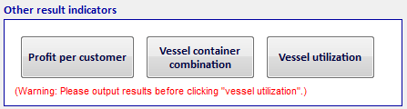

Figure : Other results indicators of weekly routing

***Step 9***: Click button “Go to vessel scheduling page”

***Step 10***: Click button “Prepare order input”. A window will show (Figure 29). Click button “Prepare order information for scheduling”. This process might take a few minute, please wait patiently until a window shows “Order information is ready for vessel scheduling”.

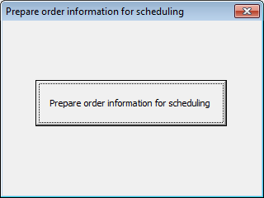

Figure : Prepare order information for scheduling

***Step 11***: Click button “Go to input parameter page of Vessel 1 scheduling”

***Step 12***: Click button “Input for vessel 1 scheduling” to load input parameters for Excel file. Input the path of the order information file in the textbox shown in Figure 30. Click button “Input order information for vessel 1”. Input the path of the order information file in the textbox shown in Figure 31. Click button “Determine routes for vessel 1”. Click button “Prepare binary parameters represent relations of legs and orders within routes” (Figure 32). Click button “Prepare binary parameters represent relations of legs and orders between successive routes” (Figure 33). This process might take a few minutes, please wait patiently.

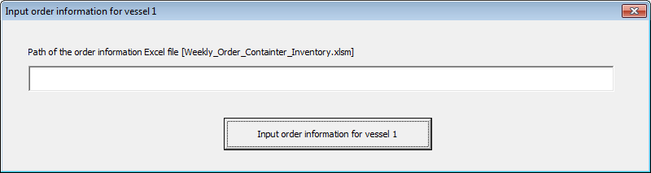

Figure : Input order information for vessel 1

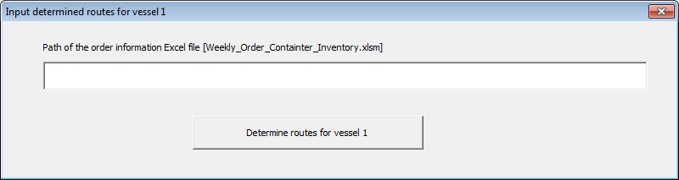

Figure : Input determine routes for vessel 1

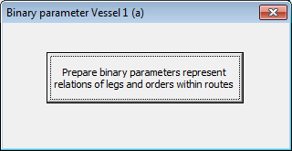

Figure : Set binary parameter (a)

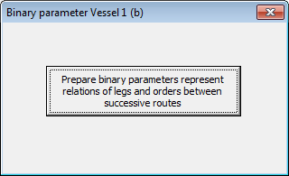

Figure : Set binary parameters (b)

***Step 13***: Check the input parameters for weekly routing. If the parameters are not correct, make the modification in AIMMS or the input Excel file. If the modification is made in input Excel file, click button “Input preparation for routing” again to repeat step 12 to reload the input parameters.

***Note: It is recommended to make the changes in the Excel files.***

***Step 14***: Click button “Go to Vessel 1 scheduling”

***Step 15***: Click button “Execute scheduling for vessel 1” and wait until the execution is completed. Figure 34 shows the results of this case. The results include estimated time of departure and arrival, container loading plan on the vessel and outsourcing volume. Containers loaded on the vessel are separated to two types: Containers delivered within a specific route and containers delivered between successive building blocks. The first type is the containers delivered within a specific building block and the second type is the containers delivered between building blocks that only occur when the demand is low.

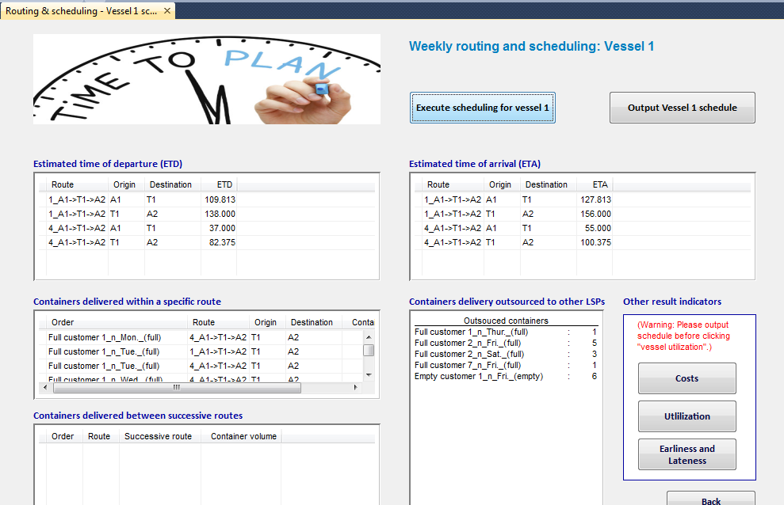

Figure : Weekly vessel 1 scheduling results

***Step 16***: Click button “Output Vessel 1 schedule”

***Step 17***: Click buttons shown in Figure 35 to check other results indicators. Results are total transportation cost, vessel utilization, and earliness/lateness of the orders and services.

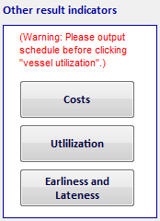

Figure : Other results indicators for weekly vessel scheduling

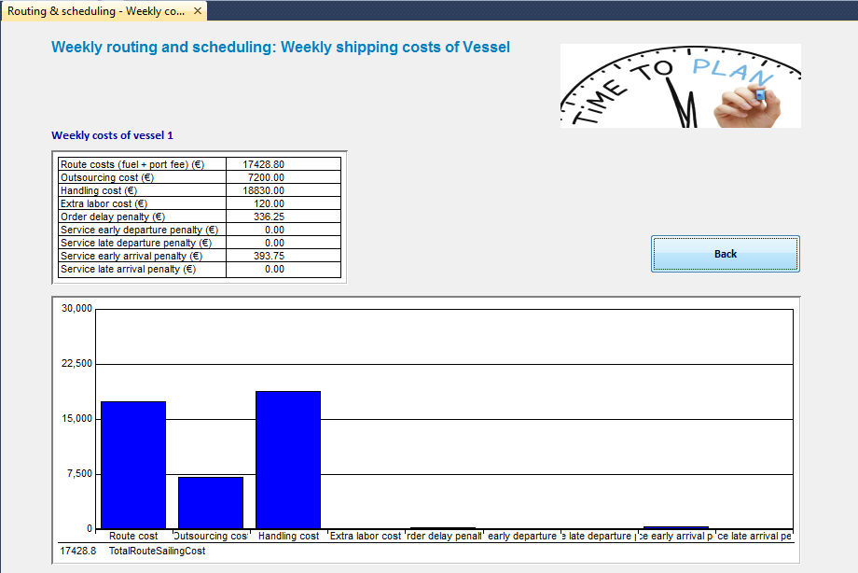

Figure : Weekly vessel scheduling results: total transportation cost

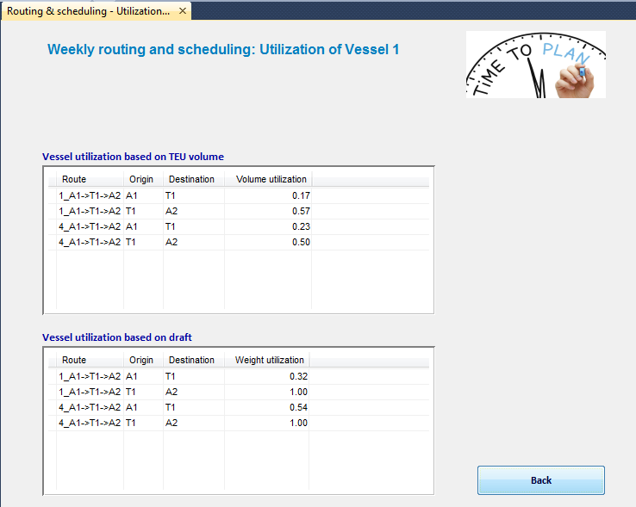

Figure : Weekly vessel scheduling results: vessel utilization

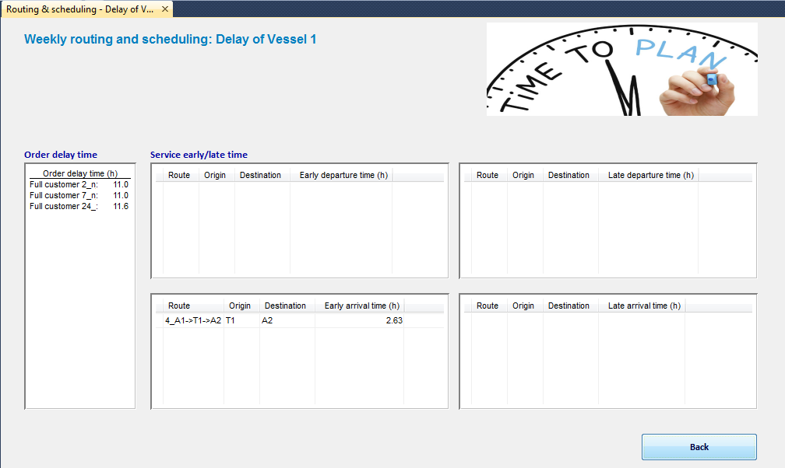

Figure : Weekly vessel scheduling: earliness and lateness of orders and service

***Step 18***: Back to vessel selection and repeat step 11 to step 17 for vessel 2 and vessel 3.

***Step 19***: Open “*Weekly_Order_Containter_Inventory.xlsm*” to further analyze the weekly routing and scheduling results.

# 5. Port stay time decision support

The decision on port stay time requires sever demand scenarios. In this tool, we consider five demand scenarios.

## 5.1 Set demand scenarios for port stay time decision

The detailed steps to set demand scenarios are shown as follow:

***Step 1***: Open “*Tactical_DemandScenarios.xlsm*”

***Step 2:*** Set order size for base scenario in sheet “Order_Scenarios” in the cells marked with blue.

***Step 3***: Set order size for scenario 2, 3, 4, 5 by changing the percentage in sheet “Order_Scenarios” in the cells marked in orange.

***Step 4***: Set customer information including TEU factors, average weight, outsourcing cost, handling cost, price of own sailing and price with outsourcing in sheet “Order_Scenarios” in the cells marked with yellow.

***Step 5***: Save and close file “*Tactical_DemandScenarios.xlsm*

## 5.2 Set input for routing

***Step 1***: Open “*Tactical_Routing_Input.xlsm*”

***Step 2***: Set basic input that is the same as setting input for weekly routing.

***Step 3***: Go to sheet “CustomerInfo” and click button “Load demand”. Input the path of the file of demand scenarios and click button “Input demand scenarios”

***Step 4***: Click button “Create ranges”

***Step 5***: Click button “Generate binary parameters (flow within route)”. The process might take a few minutes, please wait patiently.

***Step 6***: Click button “Generate binary parameters (flow between routes)”. The process might take a few minutes, please wait patiently.

***Step 7***: Save and close file “*Tactical_Routing_Input.xlsm*”

## 5.3 Set input for scheduling

Open files “*Tactical_Scheduling_Input_Vessel1.xlsm*”, “*Tactical_Scheduling_Input_Vessel2.xlsm*” and “*Tactical_Scheduling_Input_Vessel3.xlsm*”. Set the basic input and service penalty cost, which is the same as the settings of weekly scheduling.

## 5.4 Execute port stay time decision support

Port stay time decision support process is executed in AIMMS with the following steps:

***Step 1***: Start AIMMS and open vessel planning tool

***Step 2***: Click button “Port stay time decision support”

***Step 3***: Click button “Routing input preparation”. Input the path of the file of demand scenario to load routing input parameters as shown in Figure 39. Click button “Input demand scenarios”

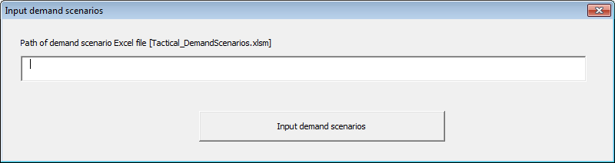

Figure : Input demand scenarios

***Step 4***: Check the input parameters for weekly routing. If the parameters are not correct, make the modification in AIMMS or the Excel file. If the modification is made in Excel file, click button “Routing input preparation” again to reload the input parameters. Figure 40 shows the input parameters for this case.

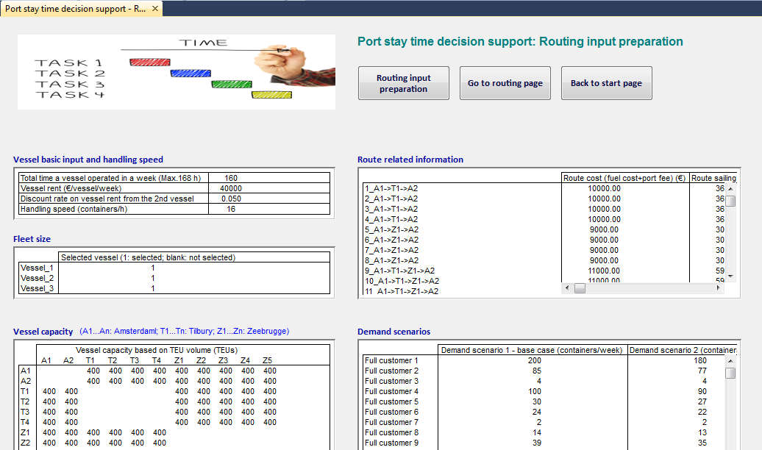

Figure : Load input parameters of routing for port stay decision support

***Note: If the customer name, origin and destination are modified, please go back to Excel file and repeat step 4 to 6 in input parameter setting for routing.***

***Step 5***: Click button “Go to routing page”

***Step 6***: Click button “Execute routing” and wait until the execution is completed. The optimization process might takes a few minutes to hours depending on the complexity of the problem. In this case, it takes 409 seconds. Figure 41 shows vessel routes of each demand scenario.

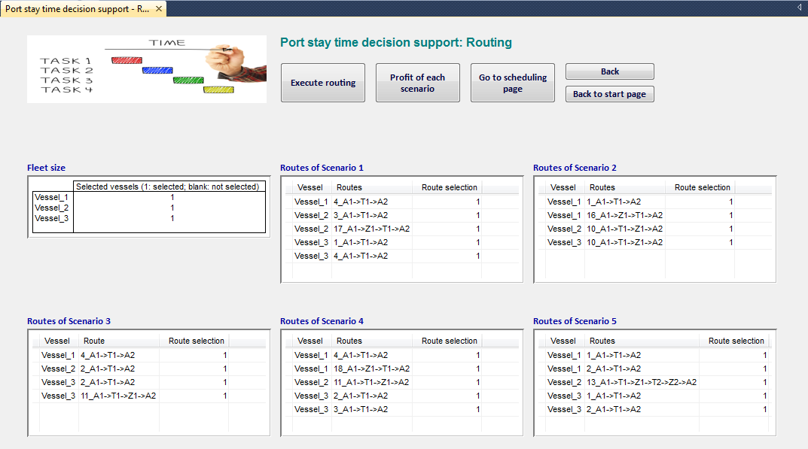

Figure : Port stay time decision support results: weekly routes of each scenario

After the execution, the routing results are stored in five Excel files. Write the path of these five files in the textboxes shown in Figure 42.

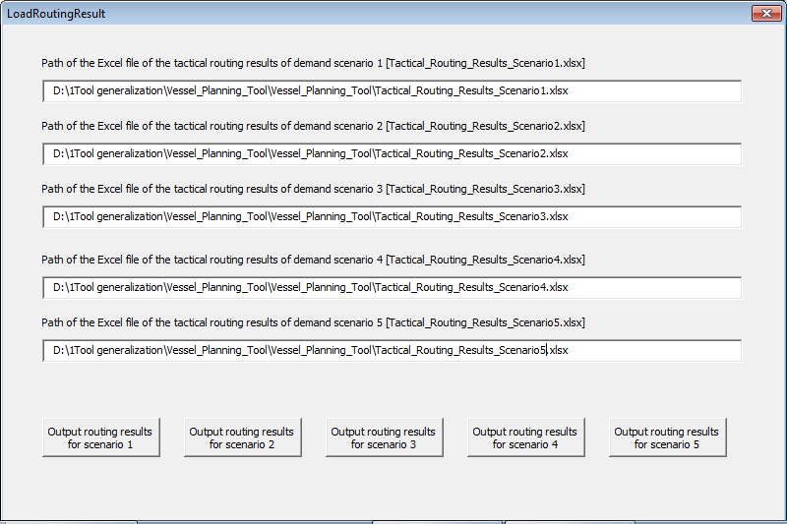

Figure : Store routing results of port stay time decision support in Excel files

***Step 7***: Click button “Profit of each scenario” to check the total profit of each scenario.

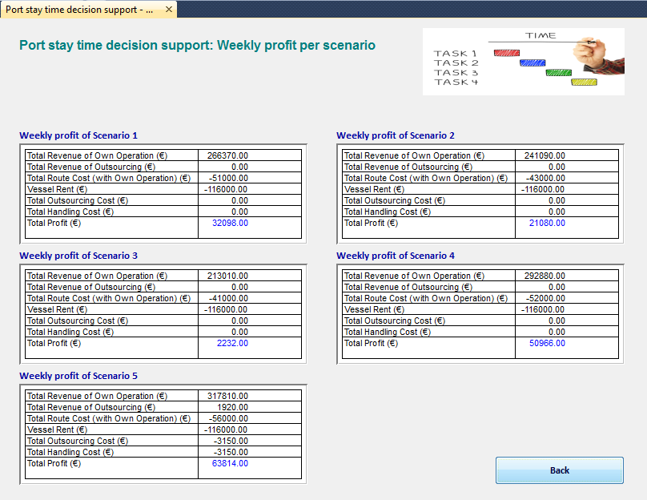

Figure : Port stay time decision support results: weekly profit of each scenario

***Step 8***: Click button “Go to scheduling page”

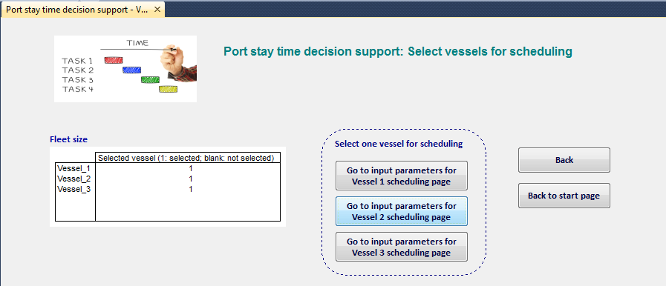

Figure : Port stay time decision support: select vessels for scheduling

***Step 9***: Click button “Go to input parameters for Vessel 1 scheduling page” to create schedules for vessel 1.

***Step 10***: Click button “Input parameters for vessel 1 scheduling”

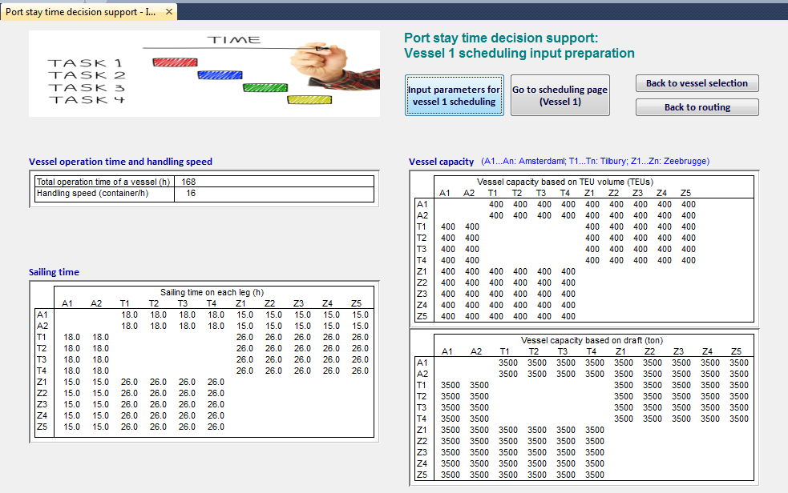

Figure : Port stay time decision support: Vessel 1 scheduling input parameters

***Step 11***: Check the input parameters for weekly routing. If the parameters are not correct, make the modification in AIMMS or the Excel file. If the modification is made in Excel file, click button “Input parameters for vessel 1 scheduling” again to repeat step 12 to reload the input parameters.

***Step 12***: Click button “Go to scheduling page (Vessel 1)”

***Step 13***: Click button “Vessel 1 scheduling (all demand scenario)” to create vessel 1 scheduling for all the scenarios. Input the path of the file of demand scenarios in the textboxes shown in Figure 46 and Figure 47 for all scenarios. Wait until the execution is completed.

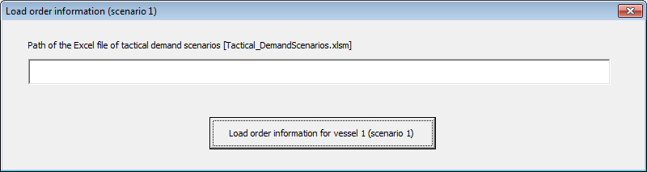

Figure : Load order information for vessel 1

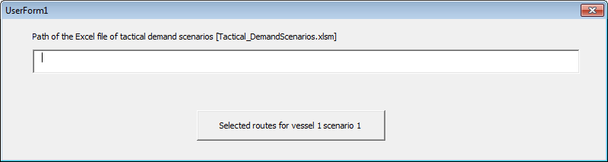

Figure : Load routes of vessel 1

Check the schedules for each demand scenario.

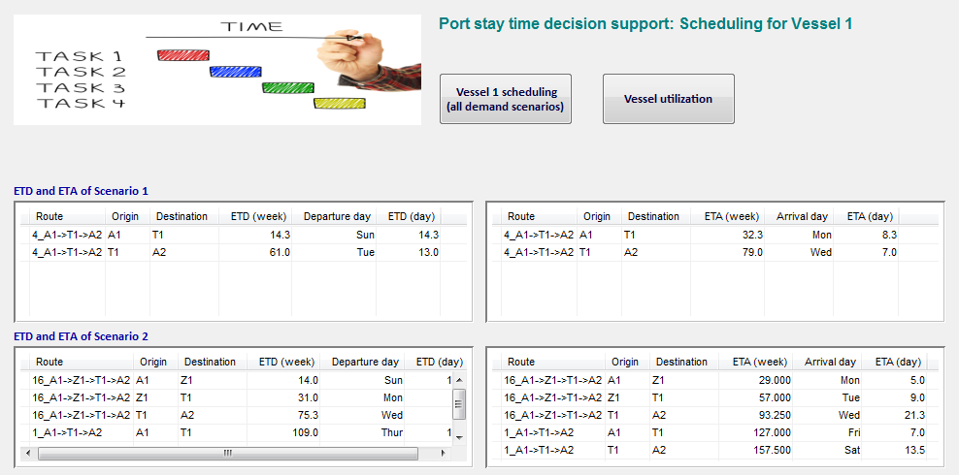

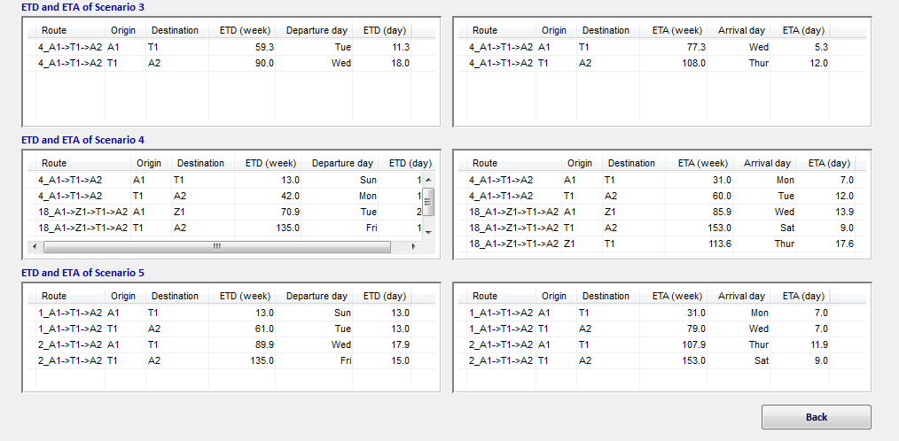

Figure : Port stay time decision support: vessel 1 scheduling results

***Step 14***: Click button “Vessel utilization” to check the utilization of each scenario

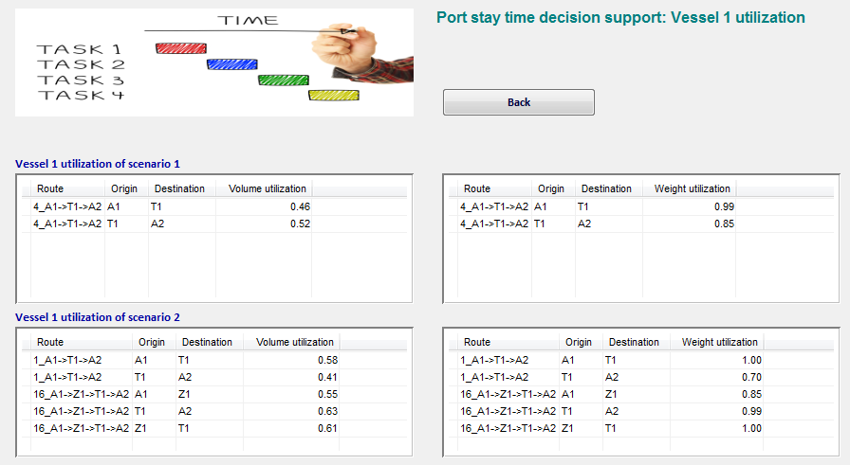

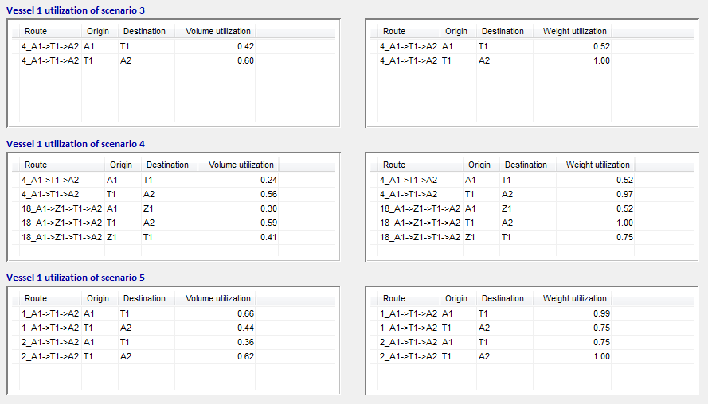

Figure : Port stay time decision support: vessel 1 utilization

***Step 15***: Back to vessel selection and repeat step 9 to step 14 for vessel 2 and vessel 3.

***Step 16***: Open “*Tactical_DemandScenarios.xlsm*” to further analyze the results. Determine the number of visit at each port and preferred port stay time window by comparing the vessel schedules of each demand scenario.